1. Go to the google and search create aws account free and click on search button after that you have to click on create free account link 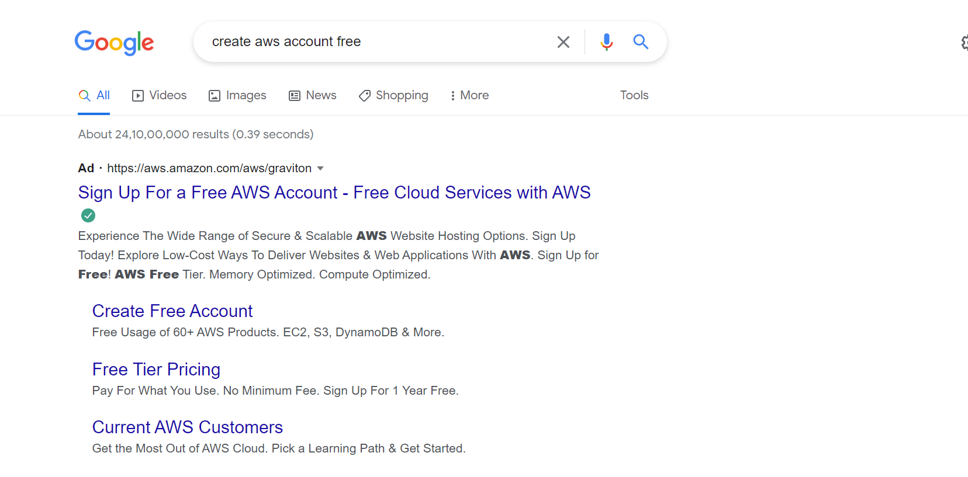
2. Click on create free account button.

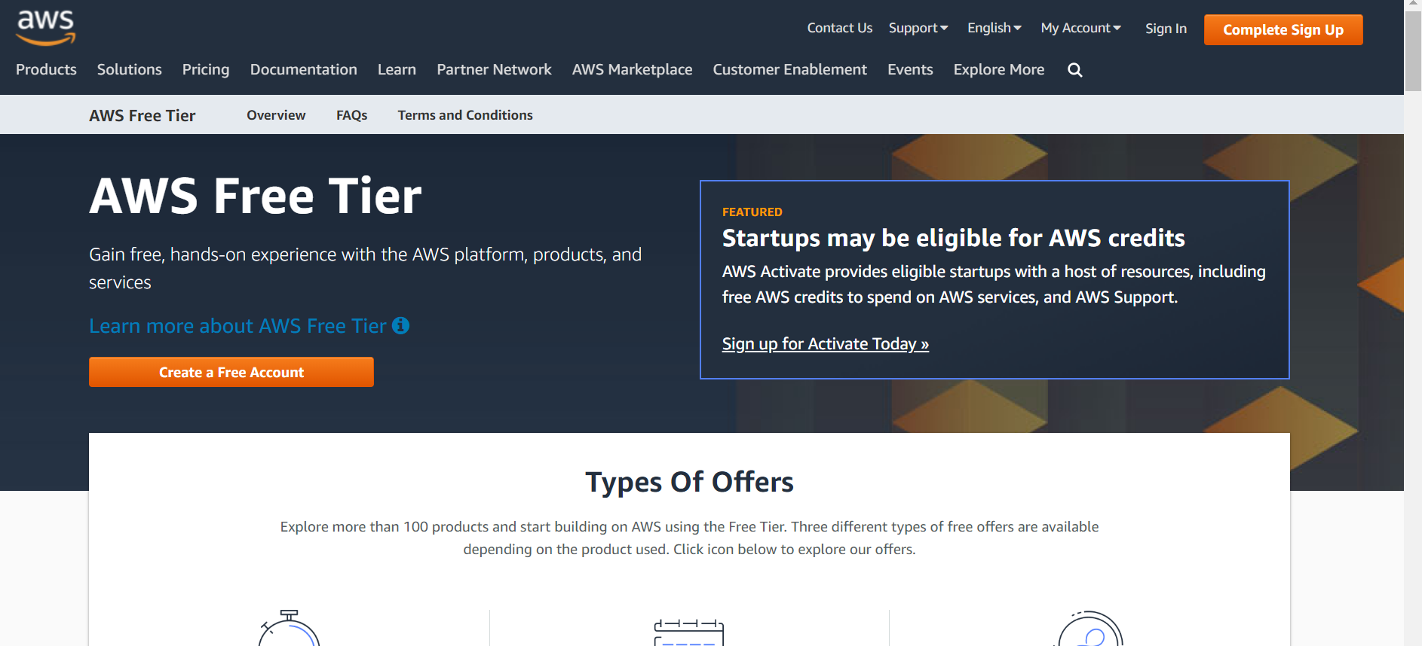

1. On this screen enter you Gmail or Outlook email address and your account name.

For ex -> Root User email address :- [xyz@gmail.com](mailto:xyz@gmail.com)

AWS Account Name -> john yonas

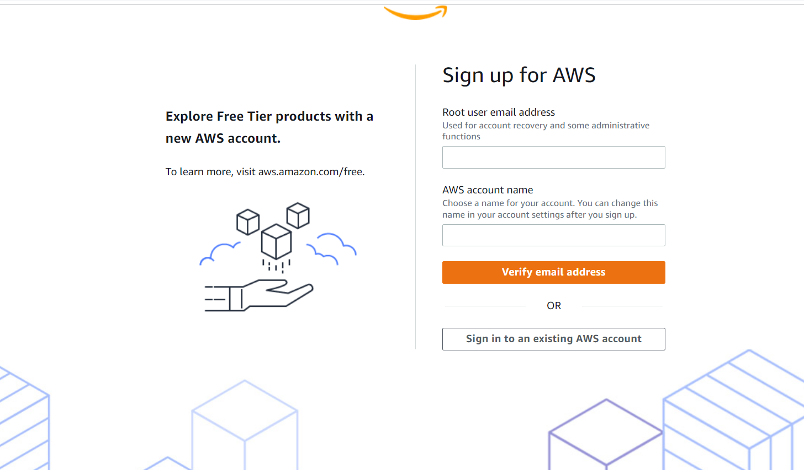

1. Go to the email address and check the email and enter the verification code. Below are the sample email.

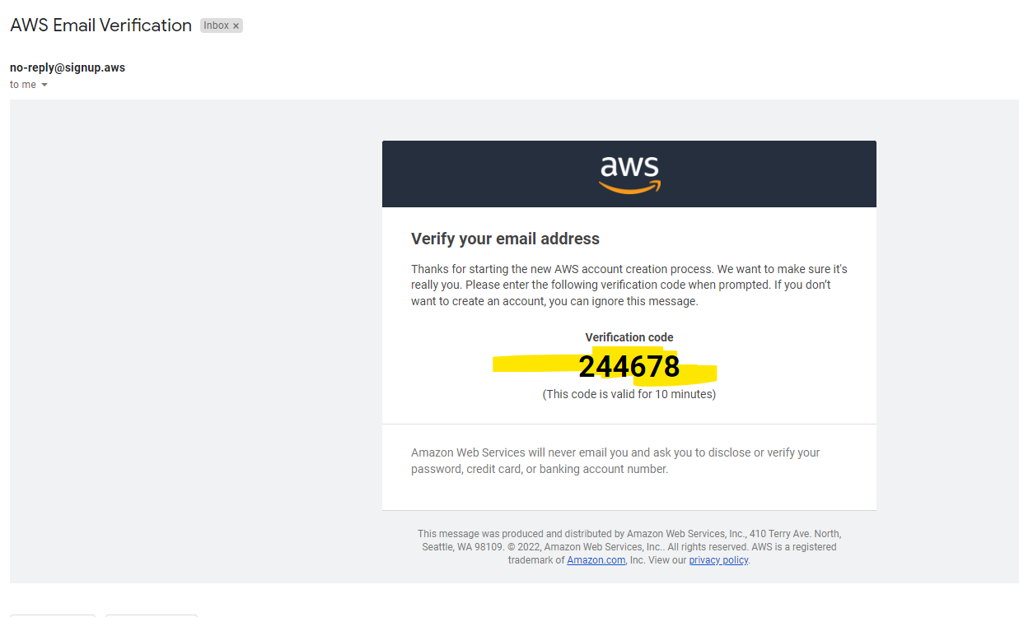

1. Enter this code in verification box.

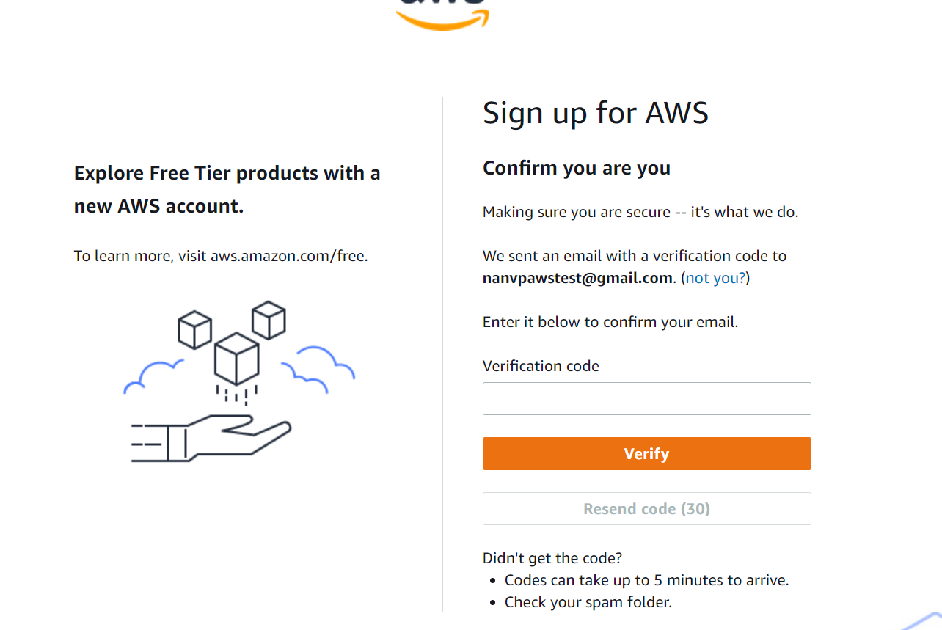

1. Once you done with email verification then you will appear in password screen please set your password and please don’t share with anyone.
2. Enter the sign-up details in AWS Screen

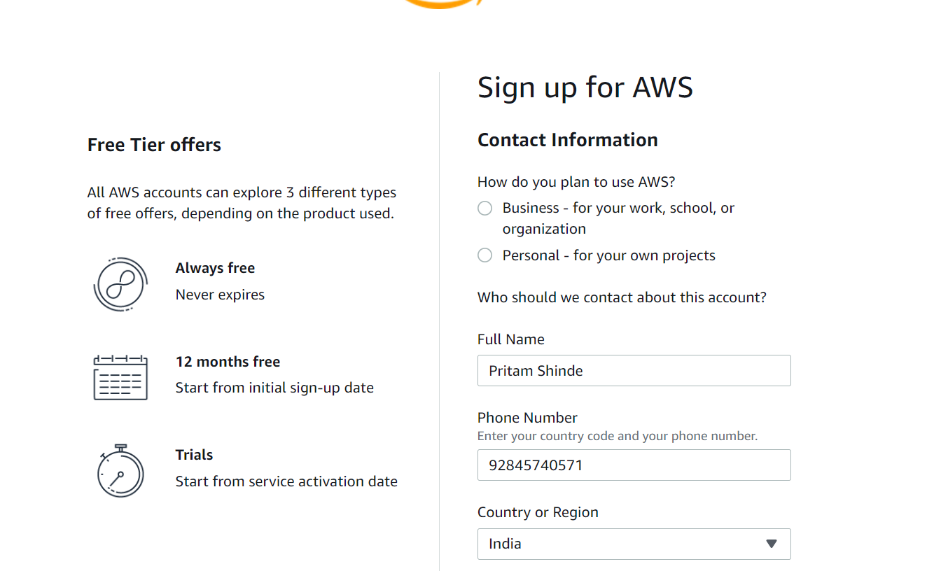

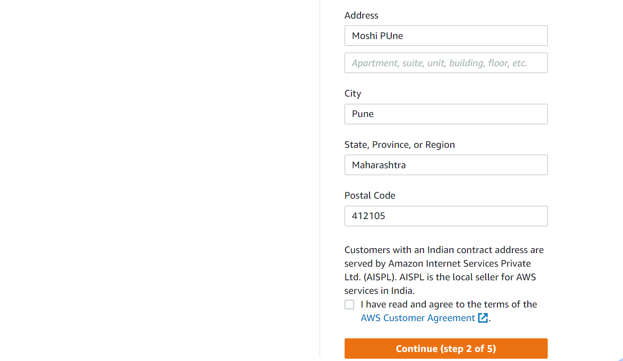

1. Enter the credit card details, this activity will charge you 2 rupees charge (INR). Don’t share these details to anyone. Also, after this don’t share your aws account details to anyone.

Note – This is your decision if you want you can enter or leave it this is just information on how to create aws account.

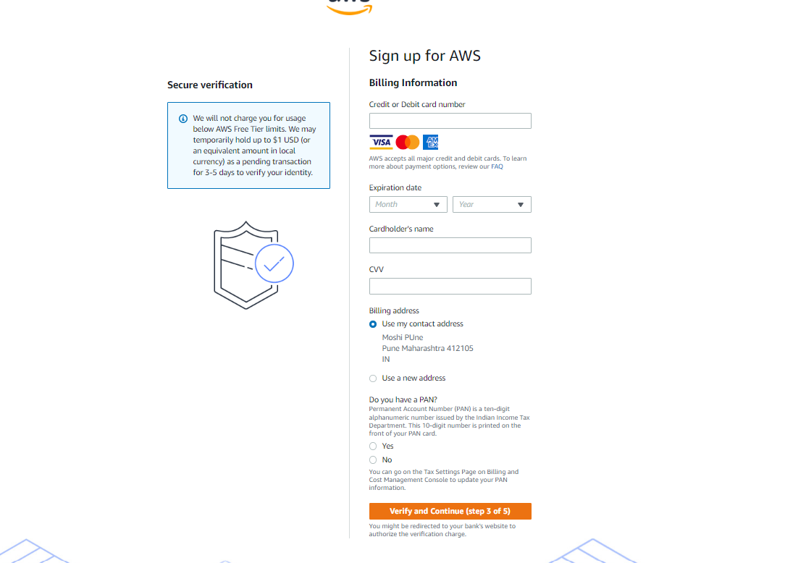

1. Follow the steps and complete your identity 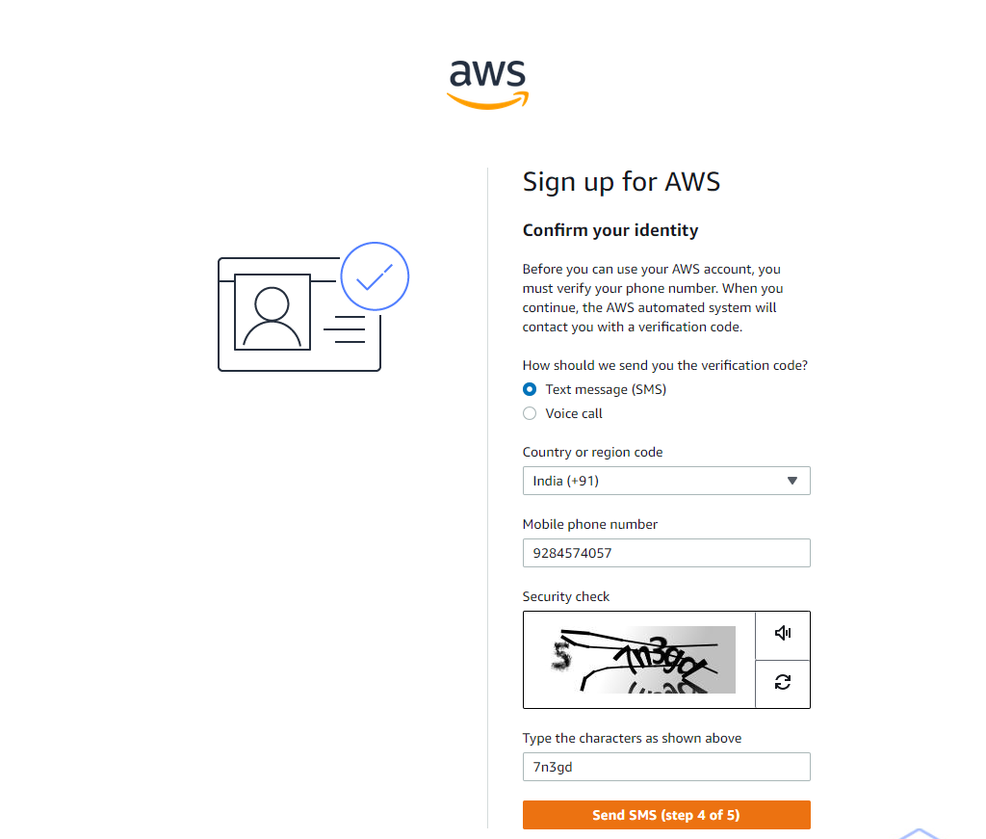
2. Confirm the code, you will get code on mobile.

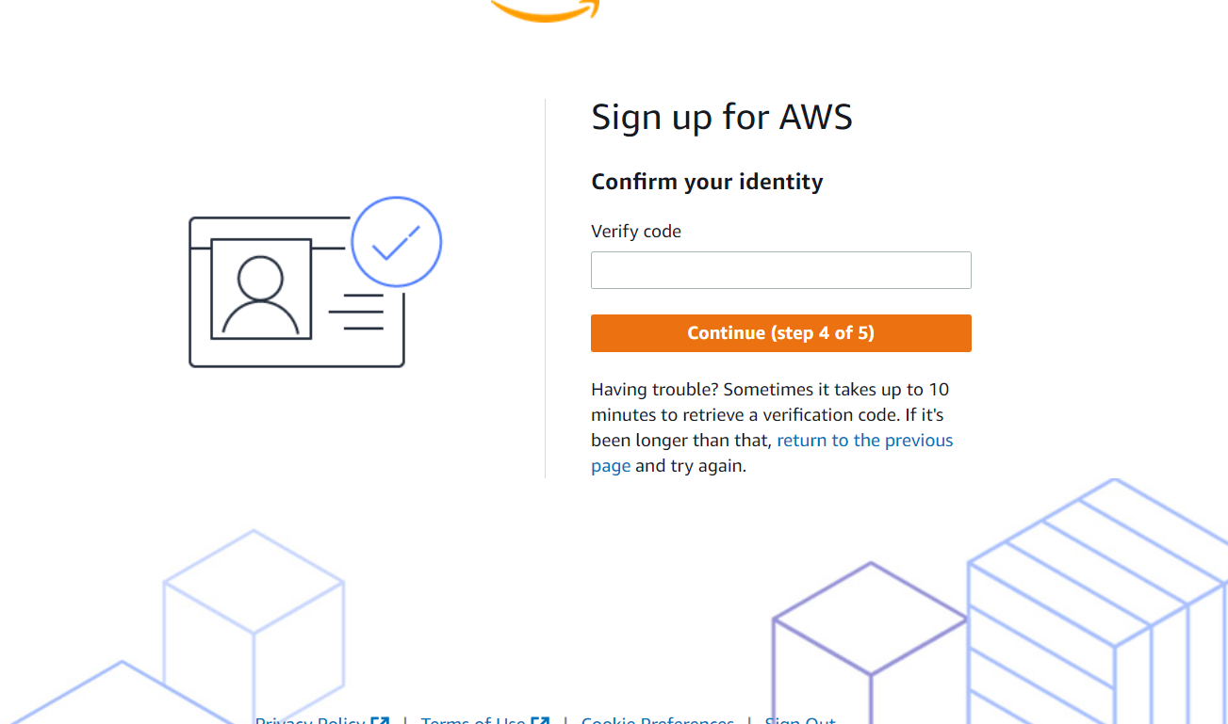

1. Please select the Basic Support-free account and click on complete sign up page.

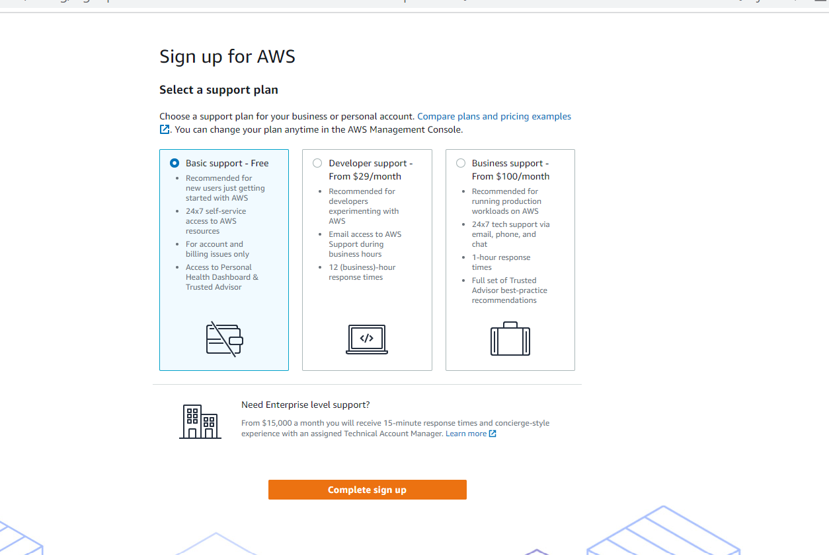

1. Click on the Go to AWS Management Console.

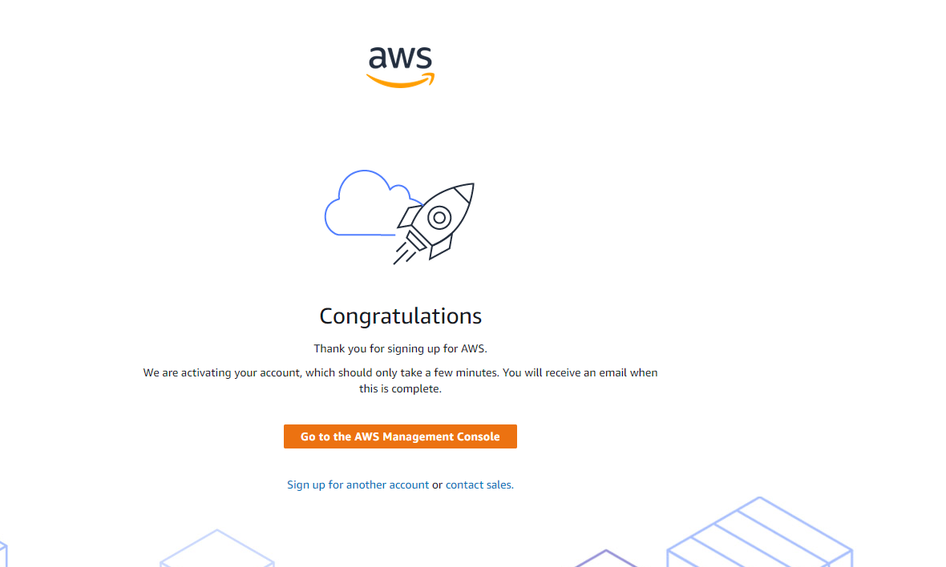

1. Enter you role and interested as below and click on sign in to the console button

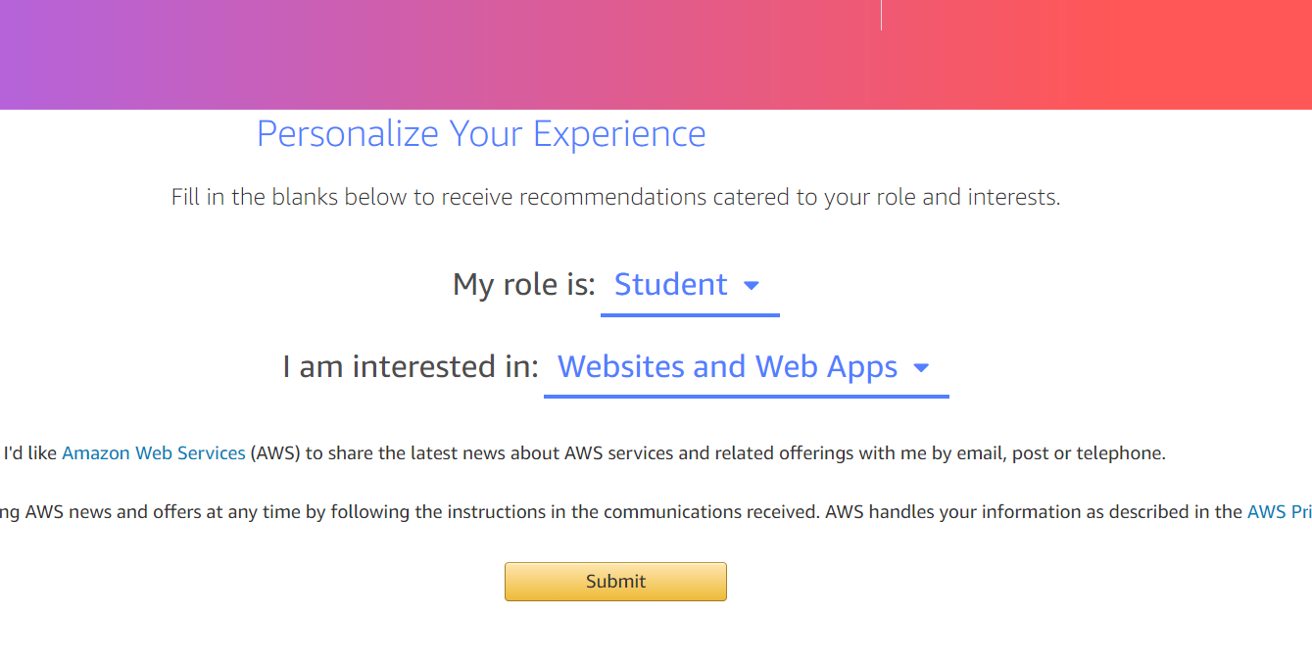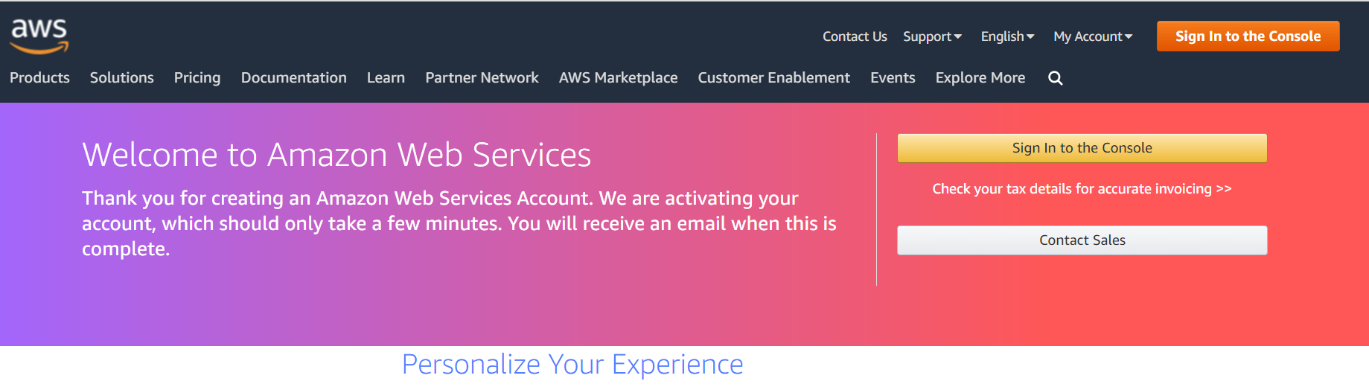

1. After that it will ask you login details enter the your email id and password and after that your console will open.

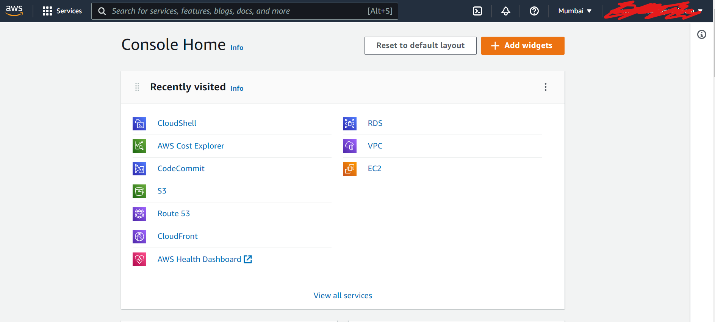

1. Check you billing Dashboard, Enter the billing keyword in search for service text box and select billing and you will get.

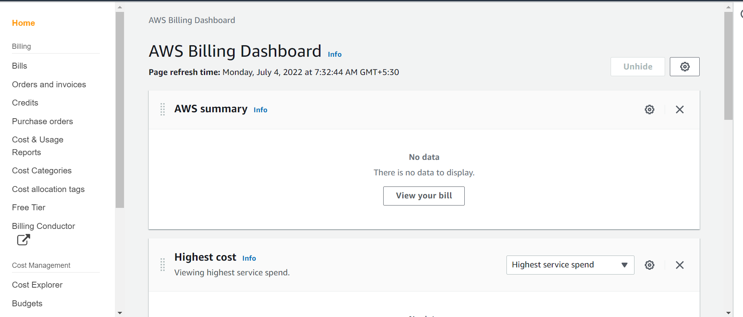

1. You have successfully created the AWS Account with the free tier.

Note - Everything is not free in aws so make sure you will be not sharing these details to anyone and make sure you have not created or selected any service.

Happy Learning 😊